DNS

1.

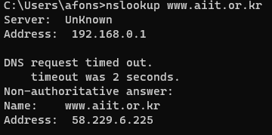

2.



3.

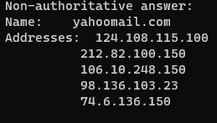

4.UDP

5. 53

6. 192.168.0.1

7. 3

8. 3

9. no

10. No request

11. dst 53, src 50701

12. 192.168.0.1

13. no answer, type A

14. 3 ansewers, Ips

15.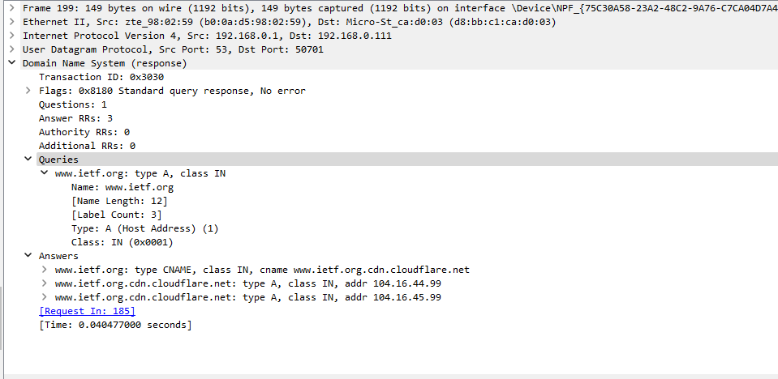

16. 2.19.42.129

17. NS, no

18. No responses

19. 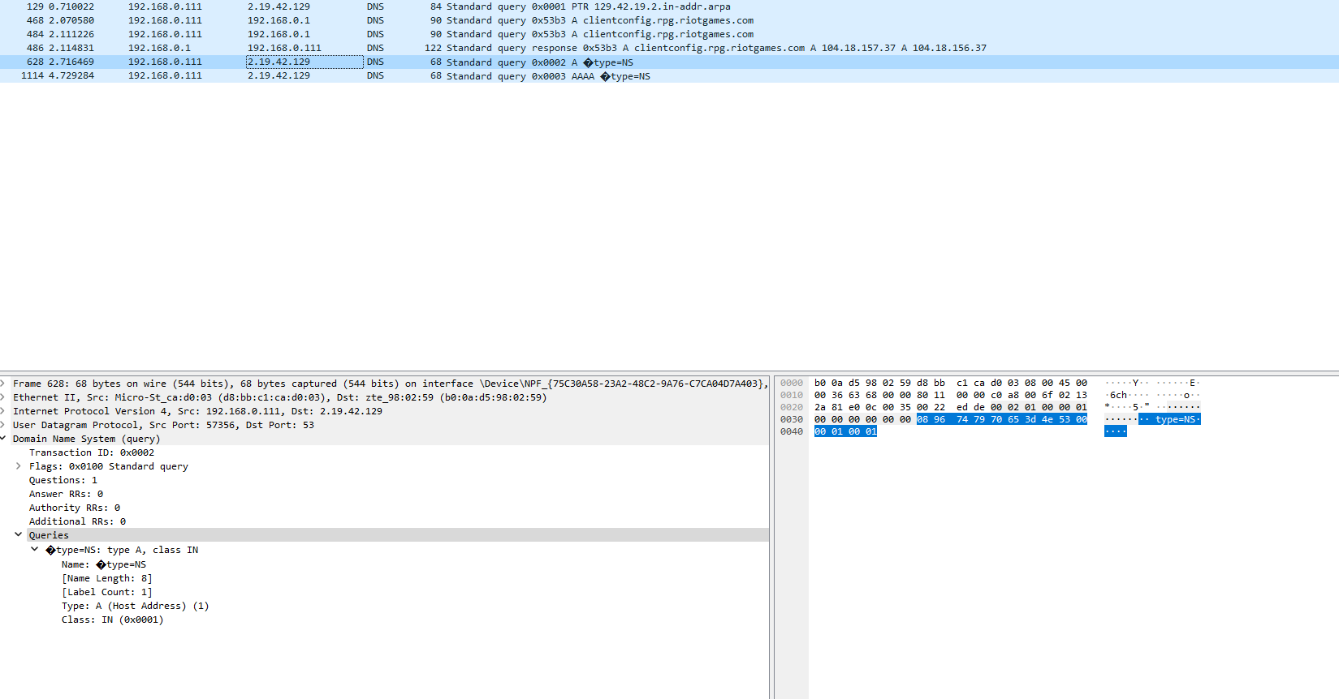

20. 18.0.72.3, no

21. no message, AAAA, no

22. no response, no answers

23.